GitHub and Git

Now that we’ve got a handle on what version control is, in this lesson, you will sign-up for a GitHub account, navigate around the GitHub website to become familiar with some of its features, and install and configure Git; all in preparation for linking both with your RStudio!

What is GitHub?

As we previously learned, [GitHub](https://github.com/) is a cloud-based management system for your version controlled files. Like DropBox, your files are both locally on your computer *and* hosted online and easily accessible. Its interface allows you to manage version control and provides users with a web-based interface for creating projects, sharing them, updating code, etc.

Signing up for GitHub

To get a GitHub account, first go to <https://github.com/>. You will be brought to their homepage, where you should fill in your information - make a username, put in your email, choose a secure password, and click “Sign up for GitHub.”

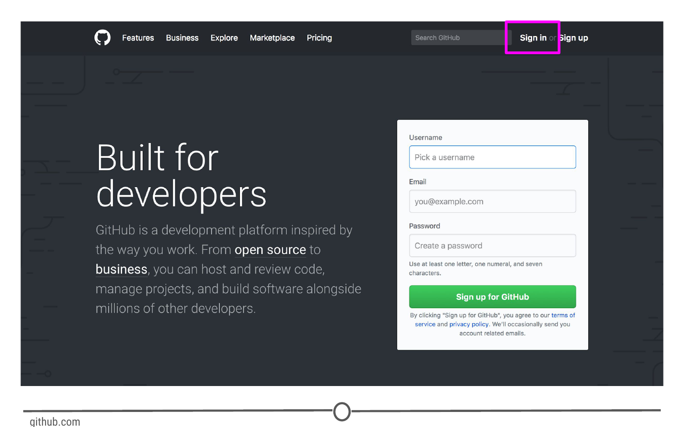

**Signing up for GitHub**

Logging in to GitHub

You should now be logged in to GitHub! In the future, to log on to GitHub, go to <https://github.com/>, where you will be presented with the homepage. If you aren’t already logged in, click on the “Sign in” link at the top.

Once you’ve done that, you will see the log in page where you will enter in your username and password that you created earlier.

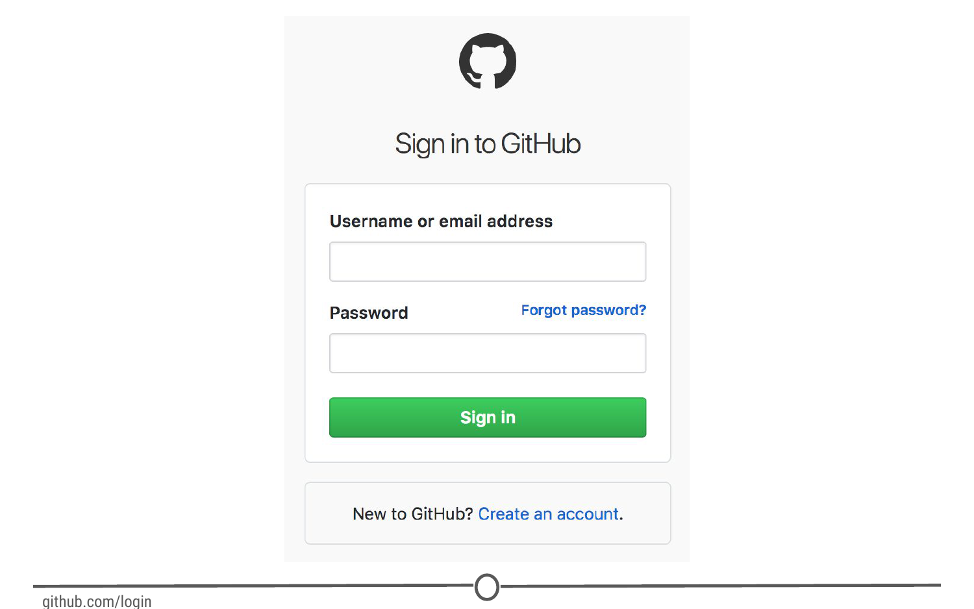

**GitHub’s log in page**

Once logged in, you will be back at <https://github.com/>, but this time the screen should look like this:

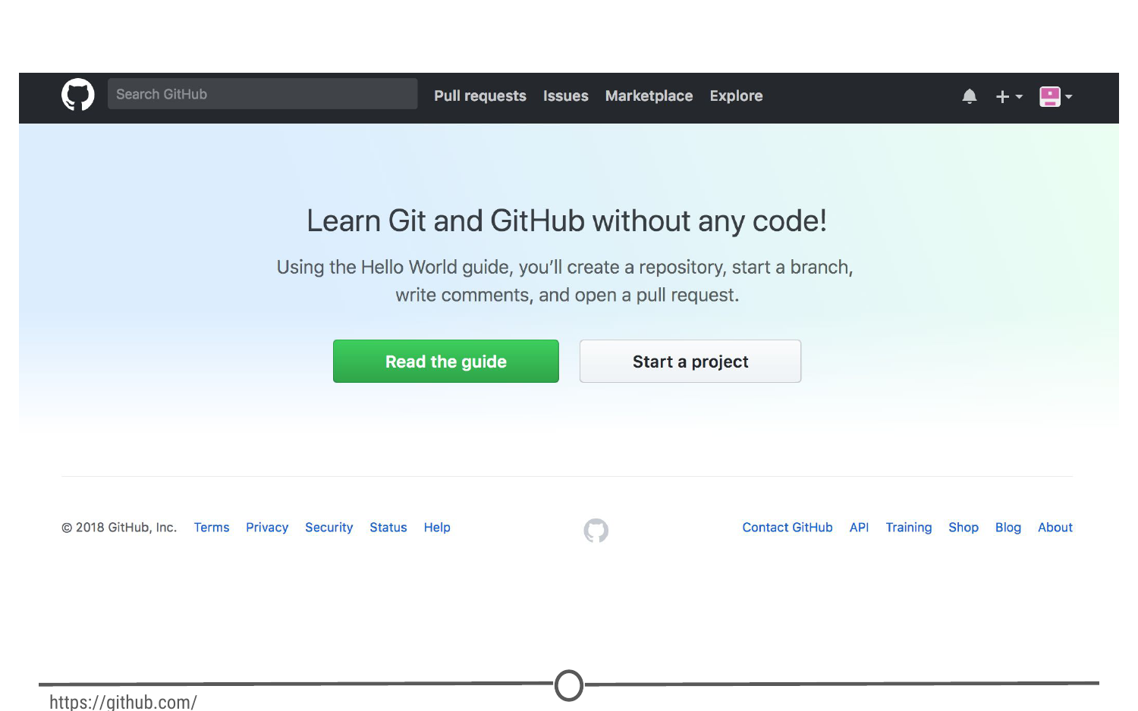

**GitHub’s homepage at [https://github.com/**](https://github.com/**)

The homepage

We’re going to take a quick tour of the GitHub website, and we’ll particularly focus on these sections of the interface:

1. User settings
2. Notifications
3. Help files
4. The GitHub guide

Following this tour, we’ll make your very first repository using the GitHub guide!

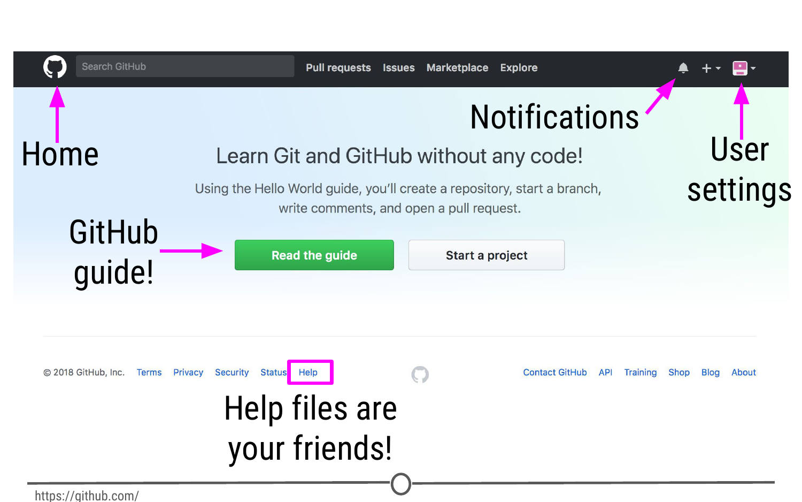

**Some major features of GitHub**

User settings

Now that you’ve logged on to GitHub, we should fill out some of your profile information and get acquainted with the account settings. In the upper right corner, there is an icon with an arrow beside it, click this and go to “Your profile”

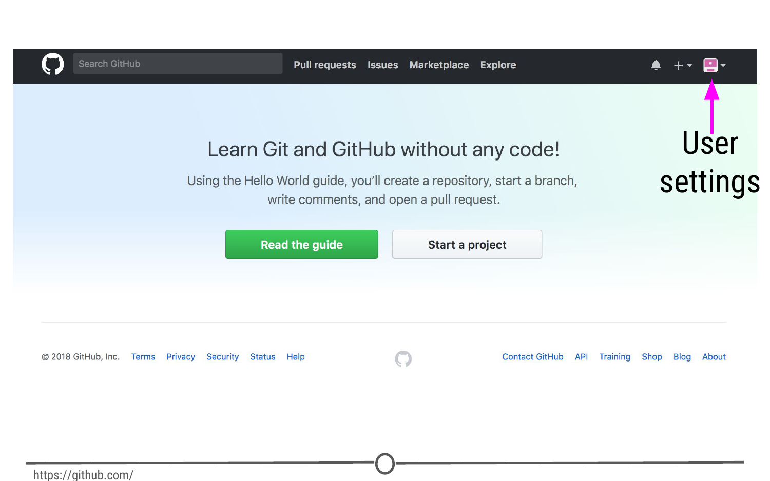

**Where to find user settings**

This is where you control your account from and can view your contribution histories and repositories.